Practice Problems Section 10 Solutions

1. Two long straight wires are separated by a distance of 0.20 m, and are both carrying current into the page.

.20 m

8 A

4 A

Wire 1 (the left wire) is carrying a current of 8.0 A and wire two (the right wire) is carrying a current of 4.0 A. The space around the wires is vacuum.

1. What is the total magnetic field (magnitude and direction) at the point halfway between the wires? **Show your work!**

The magnitude of the magnetic field due to a long, straight wire is given by $B=\frac{μ_{0}I}{2πr}$, with the direction given by the right hand rule. So, at the location at the point halfway between the wires, we have

$${\vec{B}}_{1}=\frac{\left(4π×{10}^{-7}\right)(8.0)}{2π(.10)}=1.6×{10}^{-5}\text{ T} , \text{pointing down}$$

$${\vec{B}}_{2}=\frac{\left(4π×{10}^{-7}\right)(4.0)}{2π(.10)}=8.0×{10}^{-6}\text{ T} , \text{pointing up}$$

Thus,

$${\vec{B}}_{total}=8.0×{10}^{-6}\text{ T, pointing down}$$

1. If a proton ( = 1.6 x 10-19 C, = 1.67 x 10-27 kg) is placed at the point halfway between the wires with a velocity of 1.5 x 104 m/s directly upwards along the page, what is the magnitude and direction of the magnetic force on the proton? **Show your work!**

The magnetic force on a moving electric charge is

$${\vec{F}}_{B}=q\vec{v}×\vec{B}$$

In this case, the velocity is pointing up, while the magnetic field is pointing down. Thus the velocity of the charge and the magnetic field are anti-parallel (180°) apart, and thus the magnetic force is zero.

$${\vec{F}}_{B}=0$$

1. Suppose the current in each wire in the figure is $I=0.500$ A.

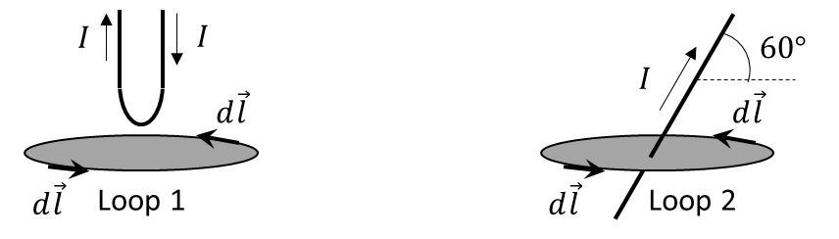

1. Solve for $\oint{\vec{B}}∙d\vec{l}$ around loop 1. **Show your work and/or explain your answer!**

Ampere’s Law states that for any closed loop, the integral of the magnetic field dotted into the displacement vector around the entire loop is equal to the magnetic constant $μ_{0}$ times the enclosed current.

$$\oint{\vec{B}}∙d\vec{l}=μ_{0}I_{enc}$$

where $I_{enc}$ is the amount of current which is going through the loop. In the case of loop 1, there is no current flowing through the loop, thus

$$\oint{\vec{B}}∙d\vec{l}=0$$

1. Solve for $\oint{\vec{B}}∙d\vec{l}$ around loop 2. **Show your work and/or explain your answer!**

In the case of loop 2, an amount of current $I=0.500 \text{A}$ is flowing through the loop. Note that Ampere’s law only references the current enclosed, not the direction of that current. In other words, the angle at which the current carrying wire flows through the loop does not matter. Thus,

$$\oint{\vec{B}}∙d\vec{l}=μ_{0}I_{enc}=μ_{0}I=\left(4π×{10}^{-7}\right)\left(0.500\right)=6.28×{10}^{-7} \text{T⋅m}$$

$μ_{0}=4π×{10}^{-7}\text{ T·m/A}$ Permeability: $μ≡K_{m}μ_{0}$

$a_{\text{cen}}=\frac{v^{2}}{r}$ Newton’s 2nd Law: $∑\vec{F}=m\vec{a}$ ${\vec{F}}_{B}=q\vec{v}×\vec{B}$

Biot-Savart Law: $\vec{B}=\frac{μ}{4π}\int{\frac{I d\vec{l}×\hat{r}}{r^{2}}}$ $B_{long wire}=\frac{μI}{2πr}$ $B_{solenoid}=μnI$

Ampere’s Law: $\oint{\vec{B}·d\vec{l}}=μI_{encl}$ Gauss’ Law for Magnetism: $\oint{\vec{B}·d\vec{A}=0}$